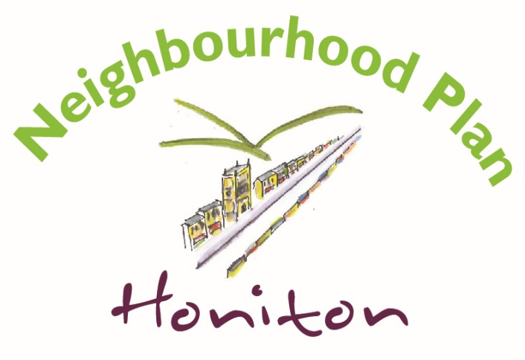

Questionnaire for Honiton businesses
Information provided about your business will NOT be published anywhere. We just need the information for statistical purposes.
1.Name of Business:

2. Main contact details:

3. What type of business is this? 4. What is your role in the business?
Owner
Partner
Director
Company Secretary
Manager
Other (please specify)

Sole trader
Partnership
Company
Franchise
Other (please specify)

5. What type of premises is this business (mostly) operated from?
In Honiton in premises owned by the business / owner
In Honiton in premises leased by the business / owner
At home
At home, but work carried out at customer premises
Our presence in Honiton is mostly “virtual”
Other (please specify)

6. How would you describe the business?
Retail (non food)
Retail (mostly food)
Café / restaurant
Pub
Hair & beauty
Repair or manufacturing
Knowledge based (eg. financial, legal or business services, consultancy, IT etc.)
Building & construction services
Health & care services
Creative/ artistic
Farming & agricultural
Other (please specify)

7. A brief description of the services or product the business offers.

8. How many people do you employ in Honiton? 9. How many of your staff live in Honiton?
1
2-3
4-5
6-10
11-25
Over 25
1
2-3
4-5
6-10
11-25
Over 25
Don’t Know

10 How many years has your company/business operated from Honiton?

11 Does your business trade 12. How important is the internet to your business?
Locally
Nationally
Internationally
Not Important
Quite Important
Very Important

13. How does the quality of services below affect your business?
 | Rarely a problem | Occasional problem | Often a problem
Internet speed or reliability
Parking space for staff or customers where you work
Ease of travel to or parking in the Town centre
Traffic congestion in Honiton
Public transport to get staff to and from Honiton

14. If your business is based in Honiton how important are the following for you being here
 | Very important | Neutral | Not important
Its where the owner or key staff live
Its central to the customer base
Its near to important suppliers
It has good virtual office or meeting places
There is a local post office
There are informal eating places
Passing trade from the A30 or other local villages
There are good local child-care facilities for staff
The availability of skilled local workforce
Attractive rural setting
Government incentives to locate here

15. If your business is based in Honiton to what extent might the following be an issue for its expansion?
 | Not likely to be a problem | Quite likely to be a problem | Very likely to be a problem
Lack of appropriate premises in Honiton
Lack of land to expand existing business premises
Lack of adequate transport infrastructure

16. Should the Honiton Neighbourhood Plan includes policies that promote working from home? E.g. new dwellings to have space designed to easily adapt to good office space.
Yes |  | No |  | Don’t Know

17. What one thing would make Honiton more attractive to business start-ups or expansion?

18 Are there additional business services that you would like to see available in Honiton? If so what are they?

Thank you for taking the time to complete this questionnaire, your answers will help the Neighbourhood Plan Steering Group to prepare a Plan for the future of Honiton
Once you have completed the questionnaire please return it to
The Neighbourhood Plan Steering Group
c/o Honiton Town Council, The Beehive, Dowell Street, Honiton EX14 1LZ

Alternatively you can scan the questionnaire and email it to deputyclerk@honiton.gov.uk or a member of the Steering Group would be pleased to collect the completed questionnaire from you. Please let us know by phoning the Town Council office 01404 42957 or email deputyclerk@honiton.gov.uk

